Fabrication of magnetic microcapsules with Fe₃O₄ nanoparticles entrapped in poly(lactic acid)
Xu Peng¹, Chen Yixi ¹, Tang Jingen ¹, Cao Xiaoyong ², Zhang Rui ^{1*}
1. College of Chemical Engineering, Nanjing Forestry University, Nanjing 210037, China;
2. Nanjing Institute of Supervision & Testing on Product Quality, Nanjing 210028, China
Abstract
We designed and fabricated biodegradable magnetic poly(lactic acid)(PLA) microcapsules with Fe₃O₄ nanoparticles in the wall based on the combination of ultrasonic emulsification technique and double emulsion-solvent evaporation method. Fe₃O₄ nanoparticles were prepared by coprecipitation method, and coated with undecylenic acid and oleic acid to improve the stability in dichloromethane. The structure and morphology of the magnetic PLA microcapsules were analyzed by scanning electron microcopy (SEM) and transmission electron microscopy (TEM), Moreover, the thermal properties of the magnetic PLA microcapsules were measured by
thermogravimetric analysis (TGA). As demonstrated by experimental results, the diameter of the uniform magnetic microcapsules was about 1 μm, and the magnetic PLA microcapsules could be easily separated from aqueous solution by an external magnetic field.
载Fe₃O₄纳米粒子磁性中空PLA微囊的制备研究
中文摘要：以聚乳酸为壁材，利用超声乳化同W1/O/W2复乳化方法相结合的方法，设计合成出了囊壁载有油溶性Fe₃O₄纳米粒子的磁性中空聚乳酸微囊。扫描电子显微镜分析（SEM）显示微囊外表面光滑，平均直径为1μm，透射电子显微镜分析（TEM）显示微囊中空结构明显，Fe₃O₄纳米粒子集中分布于囊壁结构。热重（TGA）分析方法测定磁性微囊中Fe₃O₄含量高达12%。制得的磁性微囊具有较好的复溶性，在水溶液中能稳定分散，并具有较好的磁响应性，可望成为一种有效的磁靶向给药载体材料。

Introduction
Compared to microspheres, microcapsules have attracted considerable attention due to their great potential in ultrasonic imaging, blood substitutes, catalysis, especially in drug delivery. ^{[1-5]} In the drug delivery systems, microcapsules composed of biodegradable polymers are able to protect these drugs against degradation, to control their release from the site of administration and in some particular cases, to improve their passage through biological barriers. Furthermore, the biodegradable polymers do not accumulate in a living body so that they will not inflict any harm on the body. ^{[6-8]} Poly(lactic acid)(PLA) and its derivatives have been one kind of most used synthetic polymers owing to their outstanding biocompatibility and biodegradability. ^{[9]} Until now, various techniques are available to prepare PLA microcapsules, such as double emulsion, organic phase separation, layer-by-layer assembly and spray drying techniques. ^{[10-14]}
Magnetite/polymer composite microcapsules would be of great potential for acting as carriers for magnetic drug targeting and thermo-magnetic therapy. ^{[15, 16]} Magnetic methoxy poly(ethylene glycol)-poly-(lactide) (MePLEG) microcapsules with Fe₃O₄ in the core were successfully fabricated by a facile double emulsion-solvent evaporation process.^{[17]}
In this study, one of the most widely applied magnetite nanoparticles, Fe₃O₄ magnetic nanoparticles were synthesized by coprecipitation method, and they were further coated by undecylenic acid and oleic acid to form lipophilic particles. The magnetic PLA composite microcapsules with Fe₃O₄ nanoparticles in the wall were fabricated by the combination of ultrasonic emulsification technique and double emulsion-solvent evaporation method .
1 Experimental section
PLA (Mw=10,000) was purchased from Shandong Key Laboratory of Medical Polymer Materials. Poly (vinyl alcohol) (PVA, degree of polymerization 1,800; degree of hydrolysis 89%) was purchased from SINOPEC Shanghai Petrochemical Company Limited. All other reagents were analytically pure from Sinopharm Chemical Reagent Co., Ltd.
Lipophilic Fe₃O₄ nanparticles were synthesized according to the literature. ^{[18]} Fe₃O₄ nanoparticles incorporated in shells of PLA microcapsules were produced by the combination of ultrasonic emulsification technique and double emulsion-solvent evaporation method, as illustrated in Fig. 1. In brief, 250 mg of PLA and 50 mg lipophilic Fe₃O₄ were dissolved in 10 mL of dichloromethane which was used as oil phase, 2 mL H₂O was used as inner water phase, these two solutions were mixed and to generate the W1/O emulsion by sonication at 80W for 60s. The obtained W1/O emulsion was then poured into 50 mL1% (w/w) PVA aqueous solution and homogenized at a the speed for 8000rpm for 1 min The obtained W1/O/W2 double emulsion was poured into 100 mL 2% (v/v) isopropanol aqueous solution and stirred at room temperature for 3-5 h to evaporate dichloromethane. The microcapsules were frozen in a 80℃ freezer and lyophilized using a freeze dryer to fully dry the capsules and sublime the encapsulated water.
Scanning electron microscopy was done on a JEOL JSM 6700F field emission scanning electron microscope (FESEM). TEM observations were conducted with a Hitachi-8100IV transmission electron microscope operating at an acceleration voltage of 200 kV. TEM samples were prepared directly by depositing the solution onto TEM grids, which had been coated with carbon. Thermogravimetric analysis (TGA) measurements were performed at a ramp rate of 10 °C/min under a nitrogen atmosphere using TGA 2050 (TA Instruments).

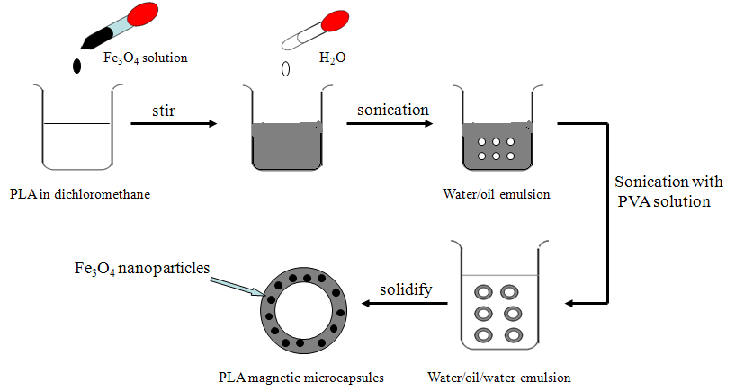
Fig. 1 Flow diagram representing the method for synthesizing iron oxide nanoparticles entrapped in PLA microcapsules.
图1. 磁性PLA微囊的制备过程示意图
2 Results

Fig. 2 shows the TEM image of Fe₃O₄ nanoparticles coated by undecylenic acid and oleic acid. From the figure, we can see that the sizes of Fe₃O₄ nanoparticles were almost uniform, obvious aggregation was absent, and their average size was 10 nm., photograph of Fe₃O₄ nanoparticles dispersed in dichloromethane was given on the bottom left of Fig. 2. Fe₃O₄ nanoparticles coated by undecylenic acid and oleic acid could be stably dispersed in the oil phase solvent.
The morphology of Fe₃O₄/PLA composite microcapsules were observed by TEM, as shown in Figure 3a, and a typical image for the magnification of one capsule is presented in Figure 3b, from the TEM morphology, the microcapsules possess spherical shape and the Fe₃O₄ nanoparticles are encapsulated mostly inside the external portion of the microcapsules. The SEM morphology of Fe₃O₄/PLA composite microcapsules prepared by the solvent diffusion method in water is shown in Fig.3c. The microcapsules were uniform spheres having a mean diameter about 1 μm. The freeze dried microcapsules were readily redispersed in aqueous medium by shaking manually, reproducing the original particle diameters before drying. It was assumed that PVA introduced into the system as a dispersing agent was adsorbed on the surface of the nanospheres during freeze drying as previously reported. ^{[19]}
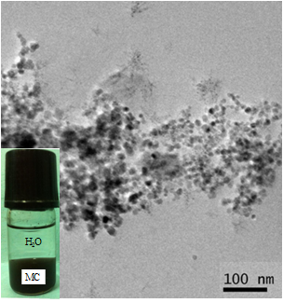
Fig. 2 TEM image of lipophilic Fe₃O₄ nanoparticles coated with undecylenic acid and oleic acid
图 2. 油酸和十一烯酸共同修饰的油溶性Fe₃O₄纳米粒子的TEM图

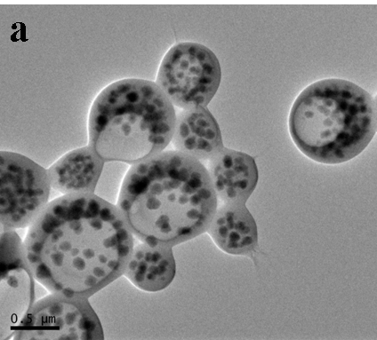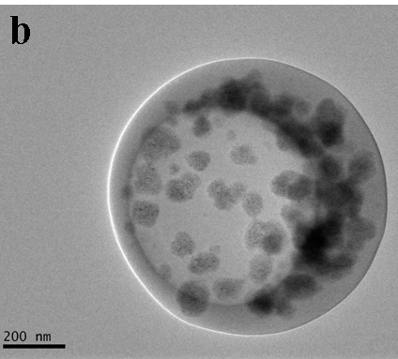
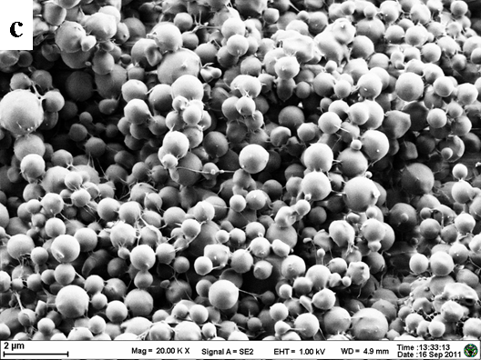
Fig. 3 TEM photographs of Fe₃O₄/PLA composite microcapsules at low magnification(a) and at high magnification (b). SEM of Fe₃O₄/PLA composite microcapsules.
图 3. 低倍率（a）和高倍率（b）下Fe₃O₄/PLA复合微囊的TEM图和Fe₃O₄/PLA c复合微囊的SEM图（c）

The samples fabricated by the double emulsion-solvent evaporation method were characterized by various measurements for the purpose of validating the methodology. Shown in Fig. 4 are the TG curves of prepared samples. The thermograms of the composite magnetic microcapsules exhibit different decomposition stages when compared with microcapsules without Fe₃O₄ nanoparticles, the decomposition stage around 300-500℃ in the thermograms of magnetic microscapsules may be attributed to the interaction between the polymer and the Fe₃O₄ nanoparticles which postpones the decomposition of the polymer. The residue above 600 ℃ is ascribed to the inorganic content of the microcapsules and thus, the weight percentages of the inorganic iron oxide nanoparticles in the microscapsules were about 12%, which was calculated from the weight residue of the composite microcapsules at 600℃.
Fig. 4 TG curves of Fe₃O₄/PLA composite microcapsules ( curve a) and pure PLA microcapsules (curve b).
图 4. Fe₃O₄/PLA复合微囊（曲线a）及纯PLA微囊（曲线b）的TG曲线

Fig. 5 shows photographs of the Fe₃O₄/ PLA composite microcapsules solution before and after 1 minute magnetic separation by an external magnetic field. As can be seen from the photographs, the Fe₃O₄/ PLA composite microcapsules are completely attracted to the magnet after1 minute. So, the Fe₃O₄/ PLA composite microcapsules could be separated from solutions by the facile separation process.
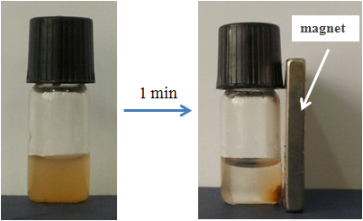
Fig. 5 Photographs of the magnetic PLA microcapsules before and (c) after 1 minute magnetic separation by an external magnetic field
图 5. 磁性PLA微囊的磁响应照片图
3 Conclusions
A novel combination of ultrasonic emulsification technique and double emulsion-solvent evaporation method was developed to fabricate Fe₃O₄/ PLA microcapsules. lipophilic Fe₃O₄ nanoparticles coated with undecylenic acid and oleic acid were entrapped in wall of PLA microcapsules, which were fabricated upon the progress of the second emulsification and the evaporation of oil phase. The sizes, structures, as well as themagnetite contents of the resultant Fe₃O₄/ PLA microcapsules were investigated by various methods. It is found that the size of the composite microcapsules was about 1μm, and the themagnetite content was about 12%. The composite Fe₃O₄/ PLA microcapsules shows good magnetic response in a magnetic field. These characteristics enable the composite Fe₃O₄/ PLA microcapsules to be used as a potential biomedical material for enhancing the contrast of dual-modality MR/ultrasonic images and targeted drug delivery systems.
Acknowledgements: This investigation was supported by a grant from the Jiangsu Province Natural Science Foundation (NO. BK20130969) and the Project Funded by the Priority Academic Program Development of Jiangsu Higher Education Institutions (PAPD). The study was also obtained the partial financial aid from the project of Student Innovation Training Program (2013).
References
[1] Pisani E, Tsapis N, Galaz Belfor, et al. Perfluorooctyl Bromide Polymeric Capsules as Dual Contrast Agents for Ultrasonography and Magnetic Resonance Imaging[J]. Adv. Funct. Mater., 2008, 18: 2963-2971.
[2] Zhang C, Hu C, Zhao Y, et al. Encapsulation of Laccase in Silica Colloidosomes for Catalysis in Organic Media[J]. Langmuir 2013, 29: 15457-15462 .
[3] Shin M J , Kim J G, Shin J S. Microencapsulation of Imidazole Curing Agents by Spray-Drying Method Using W/O Emulsion[J]. J. Appl. Polym. Sci., 2012, 126: E108-E115.
[4] Chandrawati R, Odermatt P D, Chong S, et al. Triggered Cargo Release by Encapsulated Enzymatic Catalysis in Capsosomes[J]. Nano Lett. 2011, 11: 4958-4963.
[5] Yan Y, Bjornmalm M, Caruso F. Assembly of Layer-by-Layer Particles and Their Interactions with Biological Systems[J]. Chem. Mater. 2014, 26: 452-460.
[6] Domaratzki R E, Ghanem A. Encapsulation and Release of Cladribine from Chitosan Nanoparticles[J]. J. Appl. Polym. Sci. 2013,128: 2173-2179.
[7] Pichayakorn W, Boonme P. Evaluation of cross-linked chitosan microparticles containing metronidazole for periodontitis treatment[J]. Mater. Sci. . Eng. C 33 (2013) 1197–1202.
[8] Huia P C L, Wanga W Y, Kana C W, et al. Preparation and characterisation of chitosan microcapsules loaded with Cortex Moutan[J]. Inter. J. Biologic. Macromole. 2013, 55: 32-38.
[9] Cornejo J J M, Daiguji H, Takemura F. Factors Affecting the Size and Uniformity of Hollow Poly(lactic acid) Microcapsules Fabricated from Microbubble Templates[J]. J. Phys. Chem. B 2011, 115: 13828-13834.
[10] Hwang T, Park T J, Koh W G. Fabrication of nano-scale liposomes containing doxorubicin using Shirasu porous glass membrane[J]. Colloids and Surfaces A-Physicochemical and Engineering Aspects, 2011, 392(1); 250-255.
[11] Stride E, Edirisinghe M. Novel microbubble preparation technologies[J]. Soft Matter, 2008, 2(12): 2350-2359.
[12] Eisenbrey J R, Burstein O, Kambhampati R. Development and optimization of a doxorubicin loaded poly(lactic acid) contrast agent for ultrasound directed drug delivery[J]. J. Control. Release, 2010, 143(1): 38-44.
[13] Liu R, Ma G H, Meng F T. Preparation of uniform-sized PLA microcapsules by combining Shirasu Porous Glass membrane emulsification technique and multiple emulsion-solvent evaporation method[J]. J. Control. Release, 2005, 103(1): 31-43.
[14] Daiguji H, Takada S, Cornejo J J M. Fabrication of Hollow Poly(lactic acid) Microcapsules from Microbubble Templates[J]. J. Phys. Chem. B 2009, 113: 15002-15009
[15] Sun Y, Zheng Y, Ran H. Superparamagnetic PLGA-iron oxide microcapsules for dual-modality US/MR imaging and high intensity focused US breast cancer ablation[J]. Biomaterials 2012,33: 5854-5864.
[16] Chow A M, Chan K W Y, Cheung J S, et al. Enhancement of Gas-Filled Microbubble R2* by Iron Oxide Nanoparticles for MRI[J]. Magnetic Resonance in Medicine 2010, 63: 224-229.
[17] Xu B, Dou H, Tao K, et al. “Two-in-One” Fabrication of Fe3O4/MePEG-PLA Composite Nanocapsules as a Potential Ultrasonic/MRI Dual Contrast Agent[J]. Langmuir 2011, 27: 12134-12142.
[18] Zhao H, Saatchi K, Hafeli U. Preparation of biodegradable magnetic microspheres with poly(lactic acid)-coated magnetite[J]. J. Magn. Magn. Mater., 2009, 321: 1356-1363.
[19] Kanouni M, Rosano H L, Naouli N. Preparation of a stable double emulsion (W-1/O/W-2): role of the interfacial films of the stability of the system[J]. Adv. Colloid. Interfac., 2002, 99: 229-254.

