Seed coat morphology of Sapium sebiferum in relation to water uptake mechanism
JIAN ZHOU, YUTING YIN, CUNMENG QIAN, ZHUOYI LIAO, YING SHU, SHUXIAN LI

Co-Innovation Center for Sustainable Forestry in Southern China, College of Forestry, Nanjing Forestry University, Nanjing 210037, China

Running title: Water uptake in Sapium sebiferum seeds
Corresponding author: Shuxian Li
Co-Innovation Center for Sustainable Forestry in Southern China
Nanjing Forestry University, 159 Longpan Road, Nanjing 210037, China
Tel.: 86-25-85428165
Fax: 86-25-85427165
E-mail: shuxianli@njfu.com.cn
SUMMARY
We aimed to investigate the main water entrance pathway during Sapium sebiferum seed imbibition and the relationship between seed coat structure and water uptake. Seed coat structure was observed using a scanning electron microscope (SEM). We conducted dye tracking and blocking experiments to determine the major sites of water entry into S. sebiferum seeds. Additionally, the water uptake of intact and cracked seeds was compared. SEM images showed that the S. sebiferum seed coat was composed of three layers: the waxy cuticle, the palisade layer and the parenchymatous layer, moving from exterior to interior. The cracked seeds showed significantly increased water absorption and reached saturation faster than intact seeds. This indicated that the S. sebiferum seed coat was permeable, but could delay water uptake. The results of the blocking experiments showed that S. sebiferum seeds could take up water through the entire seed coat, and the major site of water absorption was the middle part of the seed coat followed by the micropylar region and the opposite end to the micropylar region. This was in accordance with the results of the dye tracking as the first red staining was observed at the middle part of the endosperm.

Key words: water uptake, seed coat structure, TTC, Sapium sebiferum

INTRODUCTION
Water absorption plays an important role in seed germination because it is necessary for initiating biological actions. By imbibition, dry seeds can resume metabolic activity, as evident from the increase in respiratory activity. Thus germination will be retarded if seed coats hinder the admission of water. The increasing attention given to water uptake has resulted in extensive interest in the water entrance pathway of seed, especially seeds with physical dormancy (Jayasuriya, 2008). Studies have shown that different seeds exhibit individual hydration properties. For example, for Phaseolus vulgaris ‘Rajma’ and Vigna angularis seeds, water is taken up first by the lens near the hilum (Kikuchi et al., 2006). However, in some Fabaceae family members, after treatment to break physical dormancy, water enters into seeds through the extrahilar region (Hu et al., 2008, 2009), in disagreement with Baskin (2003) who considered that lens was the water entrance in legumes. In addition, de Paula et al. (2012) found that water entered through the micropylar region in thermally scarified seeds of Cassia leptophylla but through the lens in Senna macranthera seeds. Actually, most studies on the site of initial water uptake have used leguminous seeds or physically dormant seeds, and there has been no similar research on the seeds of other species.
Sapium sebiferum (Linn) Roxb. (Euphorbiaceae), known as the Chinese tallow tree or chicken tree, is a deciduous plant found in most parts of China. It has potential use as a landscape and road side plant because of its ornamental value. Additionally, the waxy coating of the seeds can be used for making soap, and the leaves and roots can be used as medicines. Moreover, it is the third most productive biodiesel-producing crop in the world, after algae and oil palm (Potts and Bolley, 1946; Ruskin et al., 1983). Thus, S. sebiferum is also considered as an important economic forest tree. For S. sebiferum, the best reproduction method is to use seeds, but this is seriously handicapped by its dormancy habits (Li et al., 2011). Previous studies have indicated that S. sebiferum seeds can absorb some water (Li et al., 2012). However, to our knowledge, no research into the exact location of water uptake of S. sebiferum seed has been conducted. In the current investigation, we have, therefore, conducted a series of studies about water uptake in S. sebiferum seeds to provide a better understanding of the main water entrance pathway during imbibition. Moreover, the permeability of a seed coat should be related to its structure, the hard and waxy seed coat of S. sebiferum did not completely retarded its water uptake as the Fabaceae family did. Investigating the influence of seed coat structural features on the water entrance pathway of S. sebiferum seeds was another objective of this study.
MATERIALS AND METHODS
Plant materials
Naturally dispersed S. sebiferum seeds were collected from the ground on the Nanjing Forestry University campus, China in November 2012. After collection, the seeds were immersed in 1% NaOH for 20 minutes to remove the white waxy aril. Subsequently, the seeds were rinsed with tap water, dried at room temperature for one week and stored in sealed plastic bags in a refrigerator at 0–5°C until use.
Seed coat morphology
The initial water uptake and amount of water absorption should be related to the structure of the seed coat. The anatomy of the S. sebiferum seed coat was examined by scanning electron microscopy (SEM) (FEI Quanta 200). According to Liao et al. (2014), the S. sebiferum seed coat includes three specialized areas, i.e. the micropylar region, the opposite end to the micropylar region and the middle part, so for anatomical studies, we observed these three regions and the surface of the seed coat. Samples of entire seeds and sections of the seeds were cut longitudinally with a single-edge blade, fixed in 4% glutaraldehyde, washed three times in a 0.1-M sodium phosphate buffer (pH 7.2) and post-fixed in 1% (w/v) OsO₄ overnight at room temperature. Following another extensive rinse with the same buffer, the samples were dehydrated in a graded series of ethanol solutions (30%, 50%, 70%, 90% and 100%). Subsequently, the ethanol was replaced with isoamyl acetate. Then, the samples were subjected to critical-point drying, mounted on aluminum stubs with double-sided adhesive and sputter-coated with gold. Finally, the samples were observed and photographed by electron microscopy (Pinzon-Torres et al., 2009).
Detection of water entrance pathway by TTC staining
The tetrazolium test was used to locate the site of water entrance through the seed coat at the beginning of imbibition. In the experiment, 200 seeds were soaked in 200 ml distilled water at room temperature for 24 hours. Subsequently, staining was done in 1% (w/v) 2,3,5-triphenyl-tetrazolium chloride (TTC) at 35°C in the dark (GB 2772-1999). Every 6 hours, 15 seeds were taken out and rinsed with tap water. The seed coat was removed to observe the TTC staining reaction. This procedure was continued until seeds were stained for 72 hours.
Water absorption after blocking different seed parts
Eight different treatments were given to locate the water entrance region by weight changes after water uptake. For each treatment, three replicates of 30 seeds were used. Before the series of experiments, every group of seeds was weighed using an analytical balance with a precision of 0.001 g to obtain the fresh weight. Then, the seed coats were made partially impermeable with Vaseline as follows: (A) control (non-blocked seed), (B) the micropylar region was blocked, (C) the opposite end to the micropylar region was blocked, (D) the middle part of the seed coat was blocked (the whole seed coat was blocked except the micropylar region and the opposite end to the micropylar region), (E) only the middle part was unblocked, (F) only the opposite end to the micropylar region was unblocked, (G) only the micropylar region was unblocked and (H) the whole seed coat was blocked. After the eight treatments, seeds were immersed into 200-ml glass beakers with distilled water at 25°C. Every 12 hours, seeds were taken out, surface-dried using absorbent paper and the Vaseline was wiped off completely. After that, the seeds were weighed again. The samples were treated with Vaseline as above and returned to the soaking water. Seed weights were determined after soaking for a further 12 hours, with a final measurement at 144 hours. The rate of water uptake was calculated and expressed as the percentage of the fresh weight. Imbibition curves for the eight treatments were constructed and compared to investigate the water uptake through different parts of the seed.
Water uptake of cracked and intact seeds
We compared water uptake in cracked and intact seeds (control) to determine whether the seed coat retarded water uptake. Three replicates of 30 manually cracked (individually with pliers) and 30 intact seeds were examined at time 0 and at 12-hour intervals for 144 hours. Each group of seeds was weighed before immersion in water and all subsequent procedures and calculations were done as in the previous assay. Water absorption curves for the seeds were constructed to determine whether the seed coat affected water uptake.
Data analysis
The results from the different treatments were analyzed separately. The significance of the treatments was tested by one-way analysis of variance (ANOVA) and Duncan’s multiple range tests was used to identify significant differences between pairs of means.

RESULTS
Seed coat structural characteristics
The integument of the seed coat and its structure are critical in determining the location of initial water entry into the seed. The SEM images of S. sebiferum revealed that the seed coat included three layers in the longitudinal section. The external layer was the waxy cuticle composed of polygonal cells (Figure 1A, B). Beneath the cuticle was the palisade layer, which comprised most of the seed coat (Figure 1D) and consisted of a single layer of macrosclereids with thick lignified walls elongated longitudinally. The macrosclereids were tightly arranged. Generally, the major axis of the macrosclereids was normal to the cuticle. It was easy to find the cell lumen of the macrosclereids (Figure 1E). The innermost layer was the parenchymatous layer, which was close to the palisade layer except in the micropylar region (Figure 1F, G). From the longitudinal section of the seed (Figure 1D, F), we also found that the palisade layer in the micropylar region was only 221.47μm thick, which was thinner than in other areas. However, the parenchymatous layer in the micropylar region was the thickest (Figure 1F). The micropyle of S. sebiferum seed was occluded (Figure 1C). Moreover, the opposite end to the micropylar region showed a protrusion without a wax layer in its seed coat, yet had the thickest palisade layer (Figure 1H, I).
Detection of water entrance pathway by TTC staining
When seeds were stained in TTC solution for 36 hours at 35°C, the first red coloured regions appeared at the middle part of the endosperm (Figure 2B). Before the dye tracking seeds were soaked for 24 hours, so when they turned red they had been soaked in water for 60 hours. The test showed that for S. sebiferum seeds, the main water entrance region was the middle part of the seed coat. After that, the red coloured regions expanded to the micropylar region and its opposite end (Figure 2C, D).
Time course of water uptake after different blocking treatments
After soaking for 144 hours, the control seeds exhibited the greatest water uptake, which was 25.09% (Figure 3A and Table Ⅰ). However, when the whole seed coat was blocked with Vaseline, there was hardly any increase in fresh mass throughout the whole experimental procedure and water absorption remained approximately the same (1.14%) (Figure 3H and Table Ⅰ). This indicated that Vaseline could completely inhibit the water uptake of permeable seeds.
The results showed that after imbibition for 144 hours the seeds in all blocking treatments except treatment H had an apparent increase in water absorption (Table Ⅰ). The water absorption of the control group (non-blocked) was significantly greater than in the treatments where only one part of the seed coat was blocked, which in turn was greater than when two parts of the seed coat were blocked except for the treatment where only the middle part was unblocked (treatment E). Among the three treatments where only one part of the seed coat was blocked, treatment C (the opposite end to the micropylar region was blocked) had the greatest final water absorption (22.5%), followed by treatment B (21.82%; the micropylar region was blocked) and treatment D (14.63%; the middle part was blocked). There were no significant differences between treatments B and C. However, both had significantly higher absorption than treatment D. These results indicated that the middle part of the seed coat could absorb more water than the other sites, and that the opposite end to the micropylar region absorbed the least amount of water. Treatments E (only the middle part was unblocked), F (only the opposite end to the micropylar region was unblocked) and G (only the micropylar region was unblocked) in which two parts of seed coat were blocked had final water absorption values of 19.69%, 10.40% and 12.42%, respectively. It was obvious that every part of the seed coat could absorb water and once again it showed that the middle part of the seed coat had the most impact on seed imbibition while the opposite end to the micropylar region had the least. Additionally, the water absorption results at 60 hours also showed the important role of the middle part of the seed coat in water entry.
Comparison of water uptake between crack and intact seeds
On the whole, cracked seeds had a more rapid increase in water absorption until approximately 60 hours (water absorption = 26.74%), after which point the rate of water uptake plateaued (Figure 4). In contrast, the water absorption of the control seeds increased slowly and the final water absorption was 25.09%. The greatest difference between cracked and intact seeds was observed after the seeds were soaked for 36 hours (9.9%), the water absorption at this time was 23.58% and 13.69%, respectively. Thus, the water absorption of S. sebiferum seeds was significantly increased after eliminating the obstacle of the seed coat, and water uptake was faster than in the control group (intact seeds). Therefore, the seed coat of S. sebiferum was permeable, but retarded the speed of water uptake.

DISCUSSION
For most species, seed germination begins with water imbibition, after which quiescent dry seeds can rapidly resume metabolic activity (Bewley, 1997). According to Ma et al. (2004), the permeability of the seed coat should be related to its structure. Previous research has shown that in many species the impermeability of the seed coat is caused by the presence of one or more palisade layers of lignified macrosclereids (Gama-Arachchige et al., 2010) and the cuticle (Bewley and Black, 1994; Villier, 1972). In this work, SEM images of the S. sebiferum seed coat revealed that it had a waxy cuticle covering a very tightly packed palisade layer (Figure 1E). This structure was similar to the testa morphology of Glycine soja, which was shown to prevent water uptake (Xu et al., 2009). Usually, the palisade layer makes seed coats harder, and for some species it also restricts seed imbibition for germination (Moïse et al., 2005; Rolson, 1978; Bewley and Black, 1994). However, by contrasting the water uptake of cracked and intact seeds, we found that the water absorption of S. sebiferum seeds was significantly increased after eliminating the obstacle of the seed coat, and water uptake was faster than the control group (intact seeds), i.e. the seed coat of S. sebiferum was permeable, but retarded the speed of water uptake (Figure 4). This was in accordance with the report of Li et al. (2012). The reason for the different performance of palisade layers in the S. sebiferum seed coat may be the presence of vacuous cell lumen of macrosclereids (Figure 1E).
Dye tracking and blocking experiments are commonly used to investigate the major sites of water entry into seeds (Jayasuriya et al., 2007, 2008; Perissé and Planchuelo, 2004; Hu et al., 2008). In our TTC staining test, the first red staining was found at the middle part of the endosperm after staining for 36 hours (i.e. 60 hours soaking in total). The blocking tests also showed that the greatest water absorption was through the middle part, including when soaked for only 60 hours (Table Ⅰ), so both experiments supported the same conclusion. However, the blocking experiments indicated that water entered into seeds through the entire seed coat. For example, when seeds were soaked for 60 hours, the water absorption of the micropylar region, the opposite end and the middle part was 8.58%, 5.40% and 11.63%, respectively (Table Ⅰ). It may be that the smaller amount of water uptake in the micropylar region and its opposite end resulted in the endosperm near these two regions not being stained after staining for only 36 hours.
The micropyle is considered one of the key parts for seed imbibition (Rangaswan and Nandakumar, 1985; Hu et al., 2008). However, in this work, the micropyle of S. sebiferum seeds absorbed some water but it was not the most important location for water penetration into the seed because the final water absorption of treatment G was a little greater than in treatment F, but far smaller than in treatment E. According to Casini (1990), at the beginning of imbibition water enters through the thinnest areas of the seed coat. Here, our SEM images showed that the micropyle of the seed was blocked, but the palisade layer in the micropylar region was the thinnest, which may have lessened the restriction on water uptake, so the final water uptake through the micropylar region (treatment G) was slightly greater than through the opposite end (treatment F). Clearly, the middle part occupies the greatest surface area of the seed coat, which may be why its water absorption was greater than that of the micropylar region or its opposite end.
In this study, our results showed that every part of the seed coat could absorb water. The amount of water movement into the seed was greatest in the middle part, followed by the micropylar region and then the opposite end to the micropylar region. However, we still do not know the initial site of S. sebiferum seed imbibition, further studies are required to elucidate that.

ACKNOWLEDGMENTS
Funding for this work was provided by the Key Forestry Public Welfare Project (201304102), the Natural Science Foundation of China (31270711). This work was also supported by the Programs for Innovative Research Team in Universities of Jiangsu Province and the Educational Department of China, and the Priority Academic Program Development (PAPD) of Jiangsu Higher Education Institutions.

REFERENCES
BEWLEY, J. D. (1997). Seed germination and dormancy. The Plant Cell, 9, 1055-1066.
BEWLEY, J. D. and BLACK, M. (1994). Seeds. Second Edition, pp.1-33, Plenum Press, New York.
BASKIN, C. C. (2003). Breaking physical dormancy in seed—focusing on the lens. New Phytologist, 158, 227-238.
CASINI, C. (1990). Seed imbibitional studies related to seed coat and seed size in soybean Glycine max (L.) Merrill. genotypes with different levels of permeability. Doctoral dissertation, Mississippi State University. Mississippi State. USA.
DE PAULA, A. S., DELGADO, C. M. L., PAULILO, M. T. S. and SANTOS M. (2012). Breaking physical dormancy of Cassia leptophylla and Senna macranthera seeds: water absorption and alternating temperatures. Seed Science Research, 22, 1-9.
GAMA-ARACHCHIGE, N. S., BASKIN, J. M., GENEVE, R. L. and BASKIN, C. C. (2010). Identification and characterization of the water gap in physically dormant seeds of Geraniaceae, with special reference to Geranium carplinianum. Annals of Botany, 105, 977-990.
GB, State Standard of the People's Republic of China (1999). Rules for Forest Seed Testing. (In Chinese).
HU, X. W., WANG, Y. R., WU, Y. P., NAN Z. B. and BASKIN, C. C. (2008). Role of the lens in physical dormancy in seeds of Sophora alopecuroides L. (Fabaceae) from north-west China. Australian Journal of Agricultural Research, 59, 491-497.
HU, X. W., WANG, Y. R., WU, Y. P. and BASKIN, C. C. (2009). Role of the lens in controlling water uptake in seeds of two Fabaceae (Papilionoideae) species treated with sulphuric acid and hot water. Seed Science Research, 19, 73-80.
JAYASURIYA, K. M. G., BASKIN, J. M., GENEVE, R. L. and BASKIN, C. C. (2007). Morphology and anatomy of physical dormancy in Ipomoea lacunose: identification of the water gap in seeds of Convolvulaceae (Solanales). Annals of Botany, 100, 13-22.
JAYASURIYA, K. M. G., BASKIN, J. M., GENEVE, R. L., BASKIN C. C. and CHIEN C. (2008). Physical dormancy in seeds of the holoparasitic angiosperm Cuscuta australis (Convolvulaceae, Cuscuteae): dormancy-breaking requirements, anatomy of the water gap and sensitivity cycling. Annals of Botany, 102, 39-48.
KIKUCHI, K., KOIZUMI, M., ISHIDA, N. and KANO, H. (2006). Water uptake by dry beans observed by micro-magnetic resonance imaging. Annals of Botany, 98, 545-553.
LI, S. X., LIU, J. J., TIAN, S. X. and YIN, T. M. (2011). Study on the causes of Sapium sebiferum seed dormancy and the methods for dormancy breaking. Journal of Nanjing Forestry University, 35, 1-4．(In Chinese).
LI, S. X., GU, H. B., MAO, Y., YIN, T. M. and GAO, H. D. (2012). Effects of tallow tree seed coat on seed germination. Journal of Forestry Research, 23, 229-233.
LIAO, Z. Y., QIAN, C. M., MA, Q. Y., XU, X. M. and YIN, T. M. (2014). Ultrastructure of seed coat and endosperm in the developing Sapium sebiferum seed. Journal of Nanjing Forestry University, 38, 44-49. (In Chinese).
MA, F., CHOLEWA, E., MOHAMED, T., PETERSON, C. A. and GIJZEN, M. (2004). Cracks in the palisade cuticle of soybean seed coats correlate with their permeability to water. Annals of Botany, 94, 213-228.
MOISE, J. A., HAN, S., GUDYNAITE-SAVITCH, L., JOHNSON, D. A. and MIKI, B. L. (2005). Seed coats: structure, development, composition, and biotechnology. In Vitro Cellular & Developmental Biology-Plant, 41, 620-644.
PERISSE, P. and PLANCHUELO, A. M. (2004). Seed coat morphology of Lupinus albus L. and Lupinus angustifolius L. in relation to water uptake. Seed Science & Technology, 32, 69-77.
PINZON-TORRES, J. A., SANTOS, V. R. D., SCHIAVINATO, M. A. and MALDONADO, S. (2009). Biochemical, histochemical and ultrastructural characterization of Centrolobium robustum (Fabaceae) seeds. Hoehnea, 36, 149-160.
POTTS, W. M. and BOLLEY, D. S. (1946). Analysis of the fruit of the Chinese tallow tree in Texas. Journal of the American Oil Chemists' Society, 23, 316-318.
RANGASWANY, N. S. and NANDAKUMAR, L. (1985). Correlative studies on seed coat structure, chemical composition, and impermeability in the legume Rhynchosia minima. The Botanical Gazette, 146, 501-509.
ROLSON, M. P. (1978). Water impermeable seed dormancy. The Botanical Review, 44, 365-396.
RUSKIN, H. A. K. (1983). Economic analysis of biofuels production in arid regions. Dissertation Abstracts International, A, 44.
VILLIERS, T. A. (1972). Seed dormancy. In Seed Biology, (ed. T.T. Kozlowski), vol.2, pp.219-281. Academic Press, New York and London.
XU, L., LI, J. D., YIN, P. P., WANG, G. J., YAN, X. F. and SUN, B. (2009). Testa morphology structure and germination characteristic of Glycine soja. Soybean Science, 28, 641-645. (In Chinese).
TABLE Ⅰ
The water absorption of S. sebiferum seeds in different blocking treatments after soaking for 60 and 144 hours.
Treatments |  | Water absorption（%）
 |  | 60 (h) | 144(h)
CK (A) |  | 17.17±0.24a | 25.09±0.75a
Only one part of seed coat was blocked | The micropylar region was blocked (B) | 16.63±0.44a | 21.82±0.70b
Only one part of seed coat was blocked | The opposite end of micropylar region was blocked (C) | 15.99±1.43a | 22.50±0.65b
Only one part of seed coat was blocked | The middle part of seed coat was blocked (D) | 9.83±0.34b | 14.63±0.11c
Two parts of seed coat were blocked | Only the middle part of seed coat was unblocked (E) | 11.63±0.098c | 19.69±0.22d
Two parts of seed coat were blocked | Only the opposite end of micropylar region was unblocked (F) | 5.40±0.133d | 10.40±0.02e
Two parts of seed coat were blocked | Only the micropylar region was unblocked (G) | 8.58±0.076b | 12.42±0.23f
 | The whole seed coats were blocked (H) | 0.63±0.015e | 1.14±0.03g
* Numbers within a column followed by different letters are significantly different at P ≤ 0.05 according Duncan’s multiple range test.
Figure legends
FIG. 1 The anatomical structure of the S. sebiferum seed coat by SEM. A, B: seed coat surface (entire seeds); C: micropyle; D: longitudinal section of the seed; E: longitudinal section of the seed coat showing the cell lumen of macrosclereids; F: the micropylar region of the seed coat (longitudinal section); G: the middle part of the seed coat (longitudinal section); H: the opposite end to the micropylar region (longitudinal section); I: the protrusion of the opposite end of the micropylar region. Abbreviations used: Cu, cuticle; Pl, palisade; P, parenchyma; Pr, protrusion; Mr, micropyle; Cl, cell lumen.
FIG. 2 TTC reaction to show the main water pathway into S. sebiferum seeds. A: control group; B: the first red staining appeared at the middle part of the endosperm; C, D: the red staining expanded to the micropylar region and its opposite end.
FIG. 3 Water absorption curves after different blocking treatments.
FIG. 4 Water absorption curves of cracked and intact seeds of S. sebiferum
Figure 1..
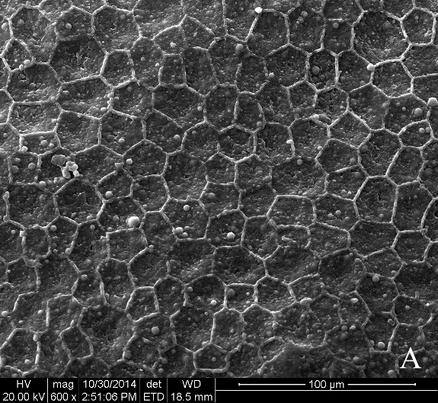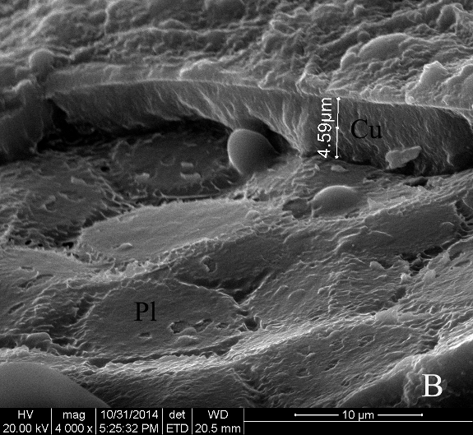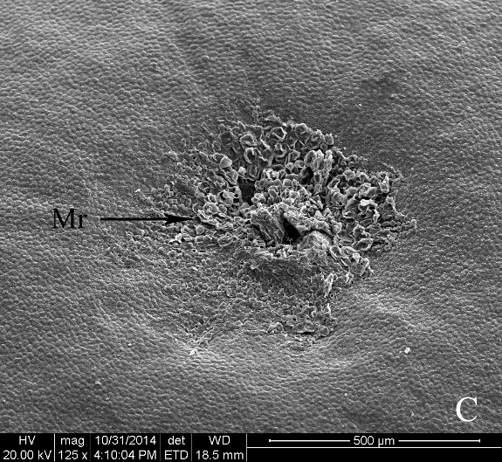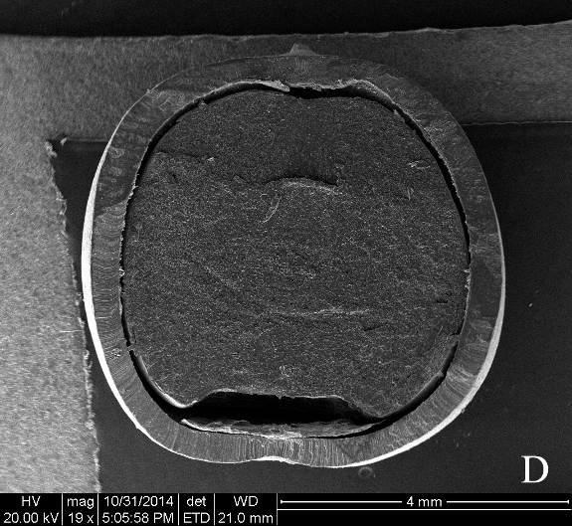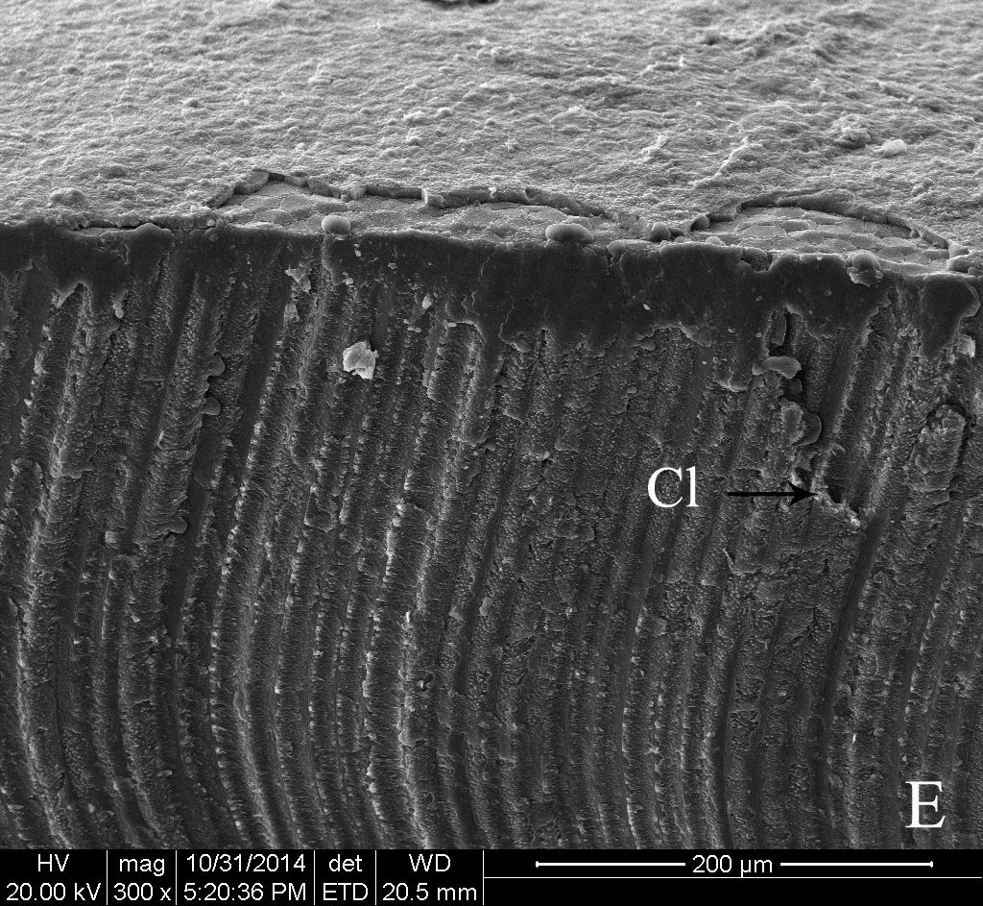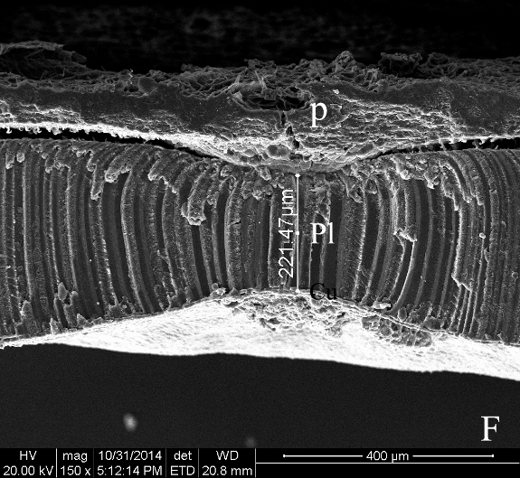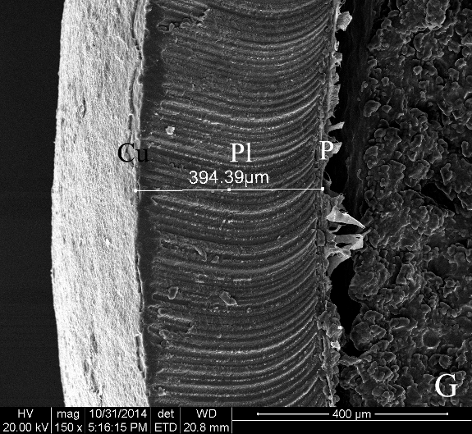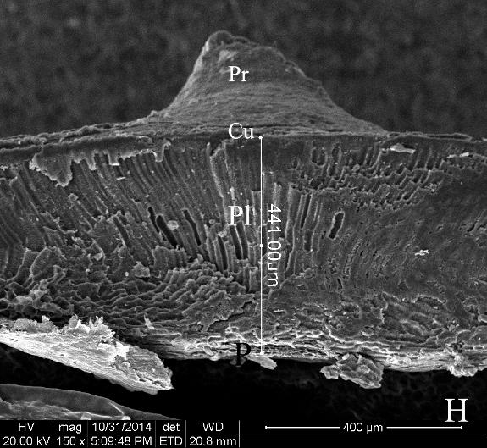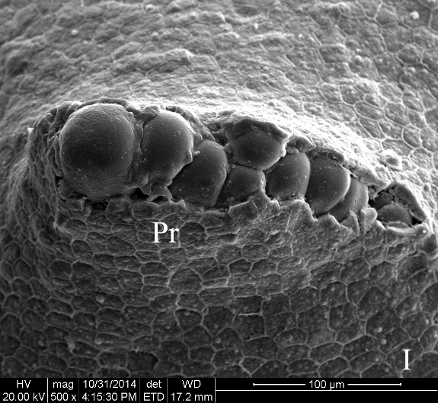
Figure 2.
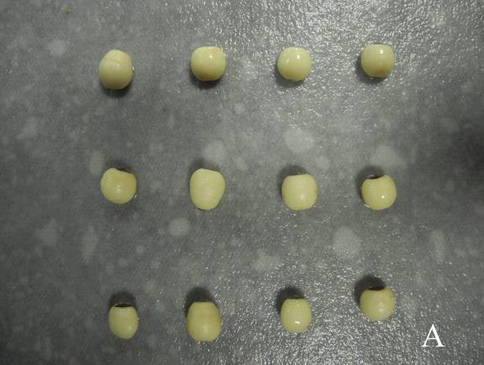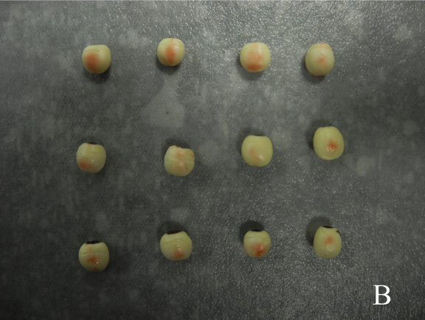
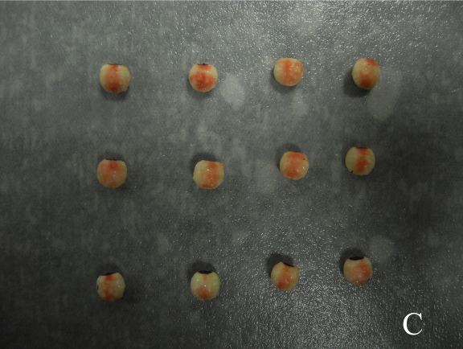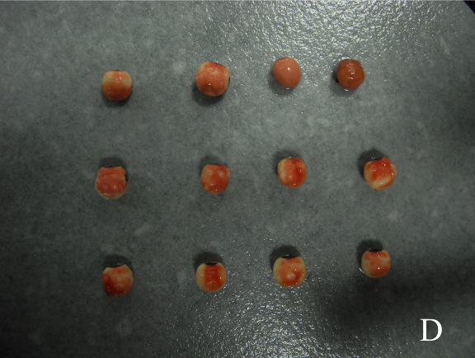
FIG. 2 TTC reaction to show the main water pathway into S. sebiferum seeds. A: control group; B: the first red staining appeared at the middle part of the endosperm; C, D: the red staining expanded to the micropylar region and its opposite end.
Figure 3.
FIG. 3 Water absorption curves after different blocking treatments. Figure 4.
FIG. 4 Water absorption curves of cracked and intact seeds of S. sebiferum.

