Cover page

Title: Analysis on Traffic Congestion in Nanjing based on Spatio-temporal Agglomeration.

Authors: YU GU
LI LIN

PAPER DEADLINE:

PAPER LENGTH:

SEND PAPER TO: YU GU
College of Automobile and Traffic Engineering
Nanjing Forestry University
No.159, Long Pan Road, Nanjing ,210037
China

Tel: 15105177872
E-mail: cissy503@126.com
ABSTRACT

With the development of city scale and the increasing number of popularity, the traffic problem is getting more and more serious. This essay digs deep into the formation of traffic congestion in Nanjing with the theory of co-existence in time-geography. Research shows that people’s trips produce agglomeration due to time and space constraints which cause spatio-temporal agglomeration and motile co-existence is the root for traffic congestion. The structure of a city especially that of metropolis, the timing of people’s trip as well as urban road network affect the formation of time and space co-existence and make the traffic congestion deteriorate to some extent. So reducing the motile co-existence caused by people’s trips on roads is an effective way to relieve the traffic congestion in big cities.

INTRODUCTION

With the development of urbanization and motorization, the traffic problems are getting more and more urgent in our cities especially in big ones, and they are spreading from the center to surrounding areas. Experts home and abroad are now doing a lot of researches with the hope to relieve the problems and coming up with many effective strategic conclusions.
The western way to study and solve traffic problems shifts from improvement of urban traffic network to taking traffic flow as a starting point and then goes further to discuss behavior mechanism of people’s trips leading to the traffic flow, which thus becomes a comprehensive field of multi-subjects. ^{[1]} While in our country, government constructs and improves traffic infrastructure to slow down this problem. As for the research on root of the traffic problem, people’s travel behavior, it just takes the first step.
In the sixties, 20th century, Hagerstrand together with his followers in Lund school invented Time-geography which offers a way to do research on human’s space behavior with regard to time and space constraints and trade off. ^{[2]}At the end of the last century , together with new technologies and new research subjects , Time-geography gets further developed and widely used in all aspects of human geography with the help of computer space analyzing technique and also provides us with a new angle to study traffic problems.^{[3-4]}
Actor-Network Theory takes city residents as a joint in the urban economic-social network and it is necessary to study the connection between joints instead of on a single joint which is reflected through residents’ moving behaviors with regard to traffic. Residents’ travel behavior is the root for traffic jams while the road is only one of the factors. So the root cause for traffic congestion lies not in too much traffic volume but in time and space co-existence resulted from agglomeration of people’s trips. Based on former research conclusions and taking Nanjing as an example, this essay explores the root for traffic congestion in Nanjing from the aspect of spatio-temporal agglomeration of people’s rips integrating all the statistics over the years.
_____________

Authors: YU GU , LI LIN , College of Automobile and Traffic Engineering, Nanjing Forestry University,No.159, Long Pan Road, Nanjing, China.

SPATIO-TEMPORAL AGGLOMERATION ON RESIDENTS’ TRIPS

Time Agglomeration of Travel Activities

There is obvious peak time for residents in Nanjing to go out, (see Figure1) respectively, 7:00-9:00 in the morning and 17:00-19:00 in the evening while there is none at noon. Figure2 shows the time cost at different period. During the peak time, residents’ trips rapidly rise and the time they spend increases, the average 31.9 mints. During other periods, there are less trips and the average time is within 30mins, which proves that there is obvious time agglomeration for residents in Nanjing to go out.
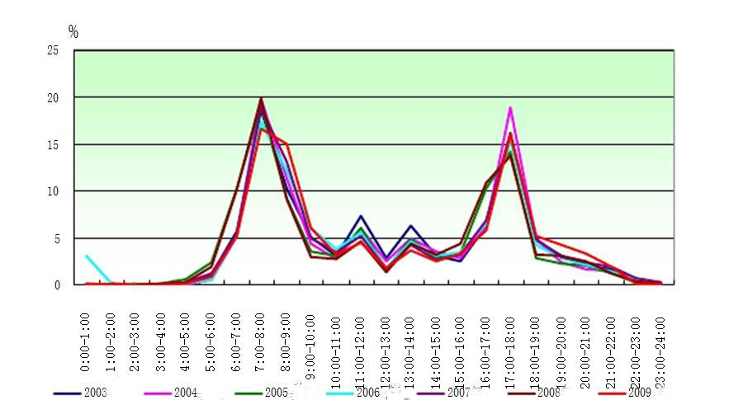

Figure 1 the travel time of residents in Nanjing over years

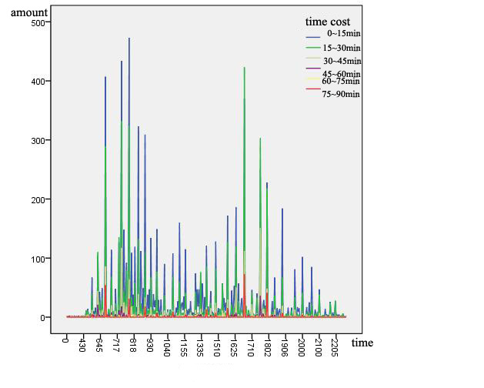
Figure 2 The time-cost of Nanjing residents in a day

Space Agglomeration of Travel Activities

Figure3 shows the desire-line of residents within urban district, 80% of which occur in the main city zone.Figure4 reflect the occurrence amount and attraction amount of each district within main city zone at peak time both in the morning and evening, among which the center ( Xuanwu district, Gulou district and Qinhuai district) enjoys higher occurrence amount and attraction amount. The suburbs have less and the more closer , the less. So there is agglomeration towards the center of the city for residents in Nanjing to go out in general.

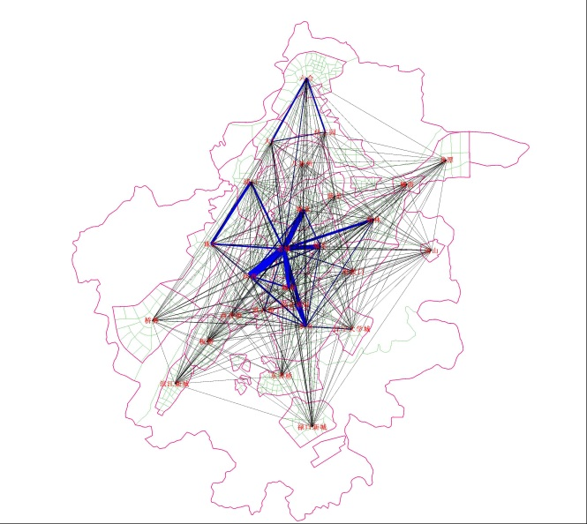
Figure3 the desire-line of residents within urban district
Morning peak time
Evening peak time
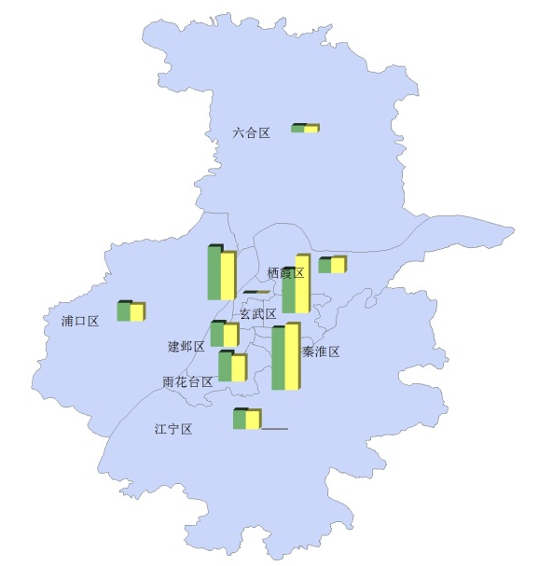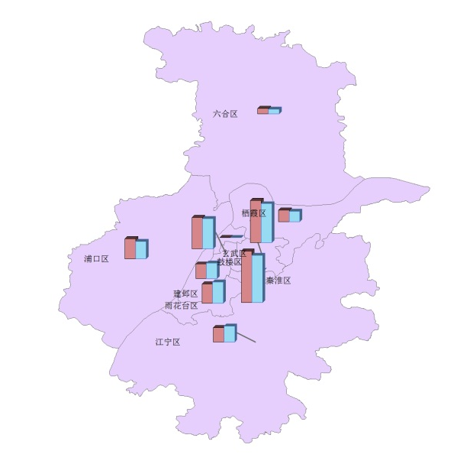
Figure 4 the occurrence amount and attraction amount of each district in peak time

Spatio-Temporal Agglomeration for the Roads

People’s activities are mainly restricted within the main city of Nanjing, which is divided into five areas as the middle, the north, the east , the south and the west of the lake. The links between the middle and the outer four areas are considered as traffic bottlenecks. The deficiency in traffic links between the middle and the north, the east as well leads to massive traffic flow. The link between the middle and the west overloads in peak time. Generally speaking, the middle suffers heavier traffic burden. Traffic congestion during peak time mainly occur in zhongyang men, shanxi road , xinjiekou and zhujiang road. (see Figure 5) .Figure6 shows the traffic volume on major roads in the main city in 24 hours , showing obvious traffic agglomeration on the roads at daytime especially during the peak times.

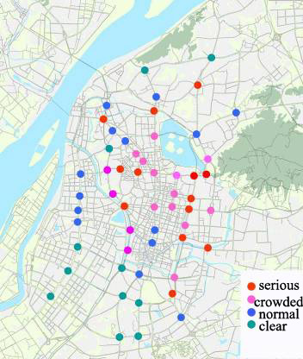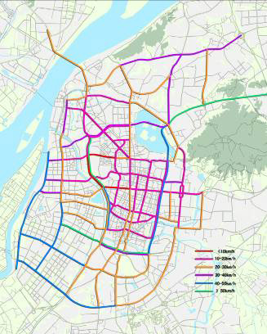

Figure5 scatter grams for the traffic on major roads in the main city

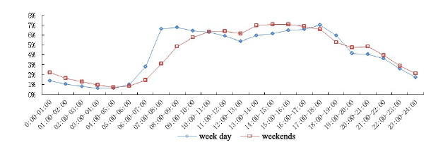
Figure 6 the traffic volume on major roads in the main city in 24 hours

THE FORMATION OF TRAFFIC CONGESTION

People’s behavior consists of a series of successive conducts in time and space. According to traditional geography, capacity, power and coupling jointly limit people’s time-space conducts and thus become time and space constraints of human behaviors.^{[5]} The residents’ travel behavior has fixed time and route which turns out to be time-space constraints. So time and space agglomeration comes into being in Nanjing.
After that the co-existence on road occurs. Current research puts this co-existence into four types as motile-instant co-existence, static-instant co-existence, static-continual co-existence and motile-continual co-existence .^{[6-8]}
With regard to the condition under which traffic congestion occur, only when two routes have time - space coexistence do traffic congestion take place . Motile instant coexistence will lead to travelers co-appearing in the same unit area and then the traffic congestion, but in very short time. Motile- continual co-existence results in traffic jams on most of the roads, because it will last for a long time. Crossroads traffic congestion are made by motile -instant coexistence which are not that severe and can be slowed down by building viaducts and reasonable dredge of traffic.
Route traffic jams are resulted from motile- continual co-existence to a lesser degree but longer time and exert tremendous influence which is the main cause to the traffic congestion inside the city. So motile co-existence including motile-instant co-existence and motile- continual coexistence give rise to traffic congestion in Nanjing city to some degree.

CAUSES FOR TRAFFIC CONGESTION IN NANJING

Three factors set off motile co-existence. The first one is the fixed time period for residents to go out, the second is agglomeration of residents movements towards certain place, the third is most residents’ choose specific routes to go out. So analysis on traffic jams in Nanjing can be done from three angles, namely time, space and route.

The view of time

Commuting ( going to work and school) is the main purpose for residents to go out in Nanjing, taking up 30.06%, and the time for commuting is concentrated which leads to time agglomeration. The traffic congestion in peak time results in more time consumption which makes it even longer to go out. So, the suggestion is put forward that residents should stagger the time for commuting or more shuttle buses should be put into use to reduce traffic agglomeration at peak times.

The view of space

Nanjing expends with it rapid urbanization. Figure 7 shows the basic pattern of city and town, 1 main city, 3 sub-city , 8 new cities and 16 towns, among which the center is made up of the main city and three sub-city. Growing city scale brings in large population. For recent years, almost 200,000 newcomers every year . Figure 8 indicates the population distribution with characteristics as obvious ring layers, that is ,the population decreases from the center to the outer parts. People are over centralized within the main city with radius of 10km taking up 60% of the in-all population which leads to traffic agglomeration in the center of main city. The roadway traffic is getting worse ,the central transportation and tidal transportation more powerful.
The relationship between population and jobs also affects the direction and flow of residents’ agglomeration. Figure 9 shows the distribution and density of jobs in which the main city takes absolute advantage. Due to the growing city scale and relatively comfortable living condition, people prefer to move to the surround area of the main city, which gives rise to separation of place to live and to work. That is also the reason why residents’ commuting agglomerates from the surrounding to the main city 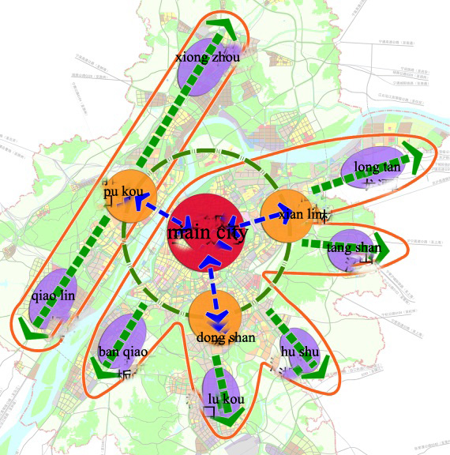

Figure7 the basic pattern of city and town

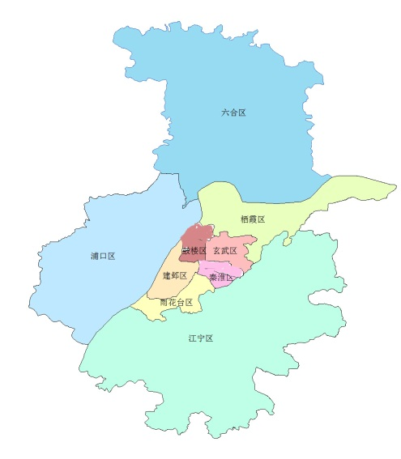

Figure8 The population distribution with characteristics

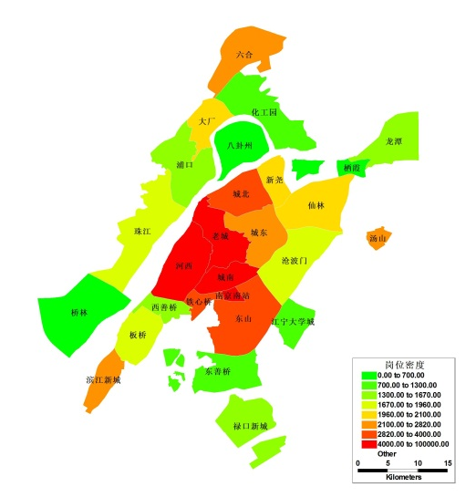

Figure 9 the distribution and density of jobs

The view of Route

Because of the current land use and preservation of this ancient city, it is difficult to build or to rebuild the collector-distributor highways like sub-arterial highways and branch ways which cannot be fully used to distribute and dredge the traffic. Pressure of long time or short time traffic focuses on main roads and high-speed channels which disturbs their functions and makes the transportation out of order. The increasing distance of movements also intensifies the traffic situation across the areas.
Meanwhile, whole way network system needs to be improved because government compounds, military regions as well as the colleges divide the network and cause a lot of dead end roads. Although the surrounding city framework begin to take shape, the construction of city road network emphasizes more on main roads instead of sub-arterial, that’s how residents’ time and space agglomeration is caused at peak times

CONCLUSION

It is not comprehensive to solve traffic problems only by taking the factors like the road condition, the residents and the motors into consideration. What’s more, we have to start from the resident’s travel behavior and explore the mechanism how traffic congestion occur.
By adopting Nanjing as an example, this essay applies theory of time and space so-existence to analyze the occurrence of traffic congestion in Nanjing from the perspective of time and space agglomeration , and it comes to conclusions as follows: due to time and space constraints residents trips will agglomerate to form time and space co-existence on roads, only under the condition of motile co-existence (motile- instant co-existence and motile -continual co-existence) do traffic congestion take place. This essay goes on to discuss the formation of traffic congestion in Nanjing from the three basic factors to cause motile coexistence. The suggestions are put forward to departments that it may concerns that they should try to slow down Nanjing’s traffic problem from the angles of structure of city spatial development and city road network layout .

Fund Project: China college students’ practice and innovation training

Reference：
[1] Chai Yanwei,Shen Jie,Zhao Ying.”Activity-based Approach for Urban Travel Behavior Research”.SCIENCEPAPER ONLINE , 2010，5(5):402-409.
[2] Hägerstrand T. ” What About People in Regional Science? ”.Papers of the Regional Science Association,1970,24: 7–21.
[3] Miller H J. ”Measuring Space-time AccessibilityBenefits Within Transportation Networks: Basic Theory and Computational Methods” .Geographical Analysis 1999,31:187-212.
[4] Miller H J. ”What About People in Geographic Information Science? ” .Computers, Environment and Urban Systems, 2003,27:447-53.
[5] Chai Yanwei, ”Time-geography:Its Orgin Concepts and Applications”.scientla geographica sinica ,1998,18(1),65~70.
[6] GU Jie, ZHOU Su-hong, YAN Xiao-pei, DENG Li-fang, ”Formation Mechanism of Traffic Congestion in View of Spatio-temporalAgglomeration of Residents’Daily Activities：A Case Study of Guangzhou”, Cientla Geographica Sinica, 2012，32（8）：921-927
[7] Parkes D, Thrift N. Times, Spaces, and Places: ”A Chrono geographic Perspective”. New York:John Wiley, 1980.
[8] Shih-Lung Shaw, Hongbo Yu. ”A GIS-based Time-geographic Approach of Studying Individual Activities and Interactions in a Hybrid Physical-virtual Space ”. Journal of Transport Geography,2009, 17:141-149.

